**HTML CSS ASSIGNMENT 1**

**PART A**

With the material provided to you. You should be pretty confident now to understand what HTML is and why CSS is required.

Your first assignment will be to make an index.html page which gives the following result.

Here are the things you need to demonstrate:

* Your page should have a header, footer and nav sections.
* Show use of Buttons, Image and Anchor tags
* Show an ordered and Unordered list.

Extra marks for showing usage of font styles.

**PART B**

**Design a website that looks like below:**

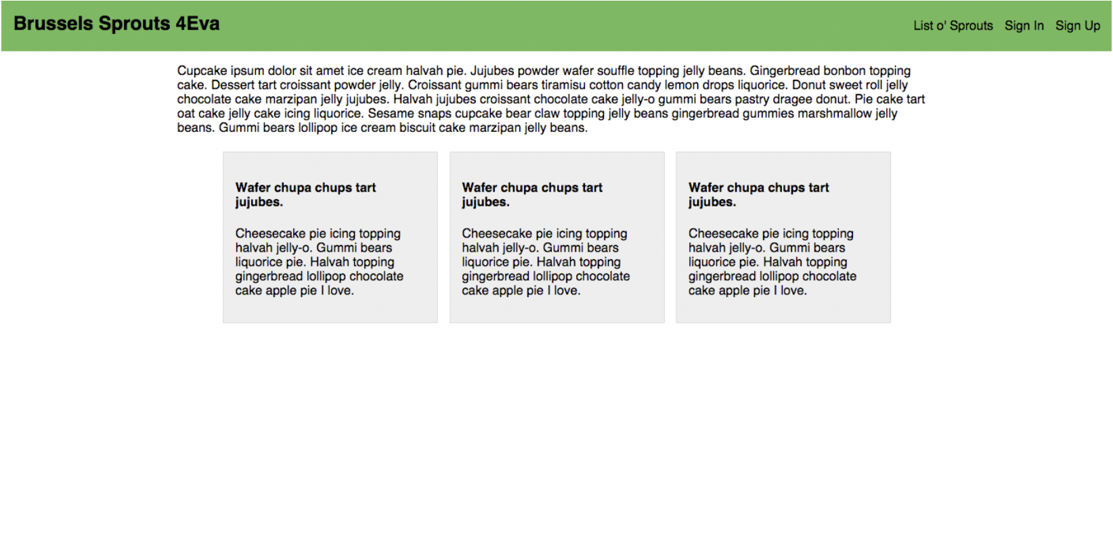

Rules for the assignment submission.

You can submit the assignment by taking a full screenshot(’s) of the above html page with the browser and submit the assignment before the due date.

Any doubts you can ask on the classroom stream comments.